

TASK
Exploratory Data Analysis ‘Forbes Athletes 1990-2020’ Dataset



Introduction
This is a complete list of the world's highest-paid athletes since the first list published by Forbes in 1990 and until 2020.

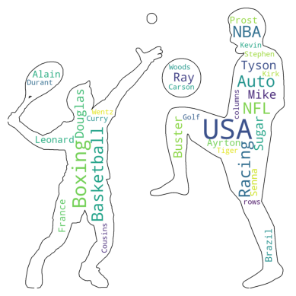

Data Dictionary:
- S.NO: Unique identifier for the person and the year (row - entry in csv file)
- Name: Name of athlete
- Nationality: Nationality of athlete
- Current Ranking: The ranking of athletes per year
- Sport: The sport practiced by the athlete
- Year: The year that the athlete was the highest paid
- Earnings: How much the athlete made in millions of dollars
- Previous Year Rank: Previous year player ranking
DATA CLEANING
- There were inconsistencies with some names that were corrected and merged to the correct athlete’s name;
- Sport names were also grouped and corrected;
- S.NO feature was redundant and was dropped entirely;
- Earnings column was renamed for a clean data frame display.

MISSING DATA
Previous Year Rank - the only column with missing data (24 count of nulls). As it was redundant and not useful for the analysis, it was dropped entirely

DATA STORIES AND VISUALISATIONS
- Overall visualisation of the dataset
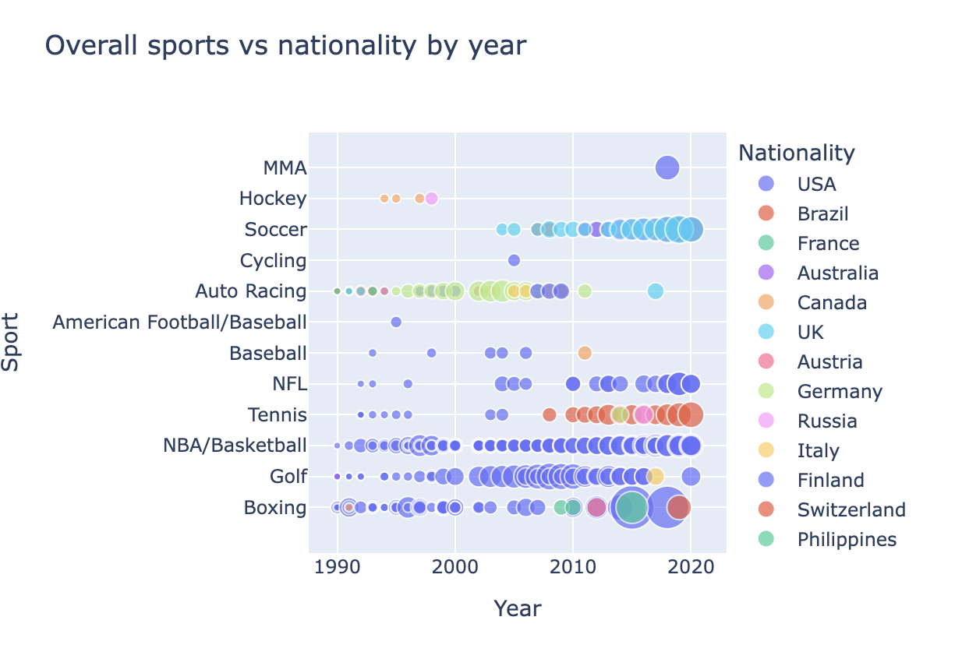
US nationality seems to be dominant nationality in particular in sports like boxing, NBA/Basketball and golf.
- Number of players by nationality
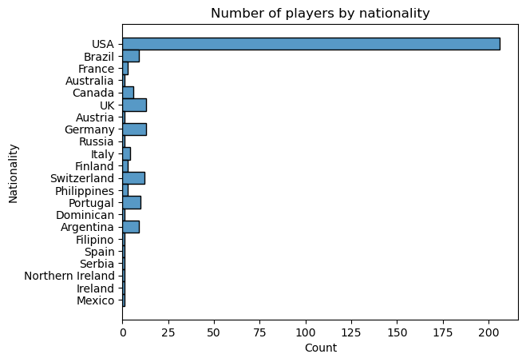
Out of 301 players, 206 are from USA.
- Total earnings by nationality
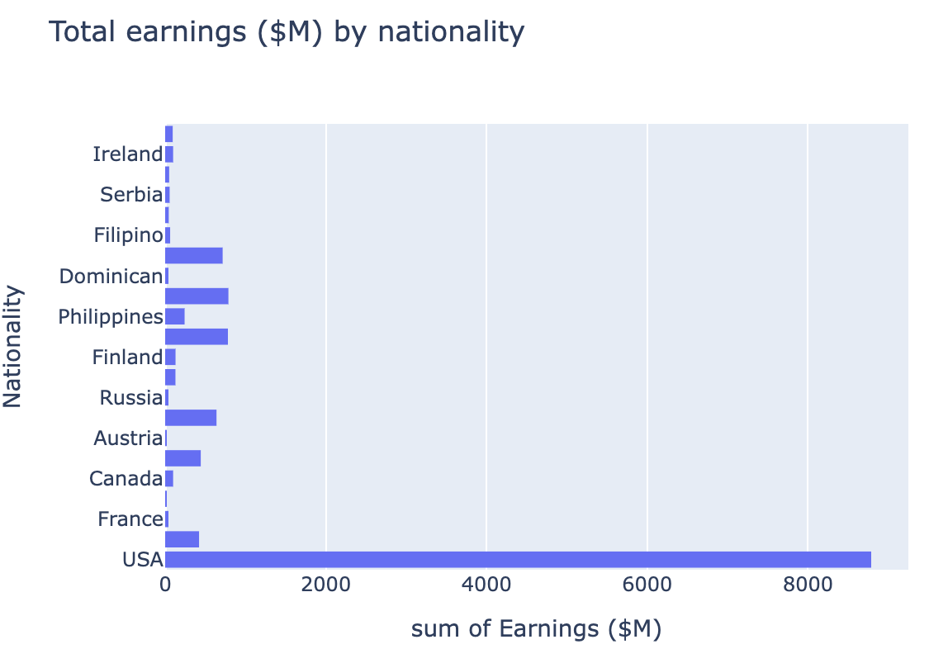
USA also accumulated the highest pay of nearly $9 billion from 1990 to 2020.
- What is the highest paid sport?
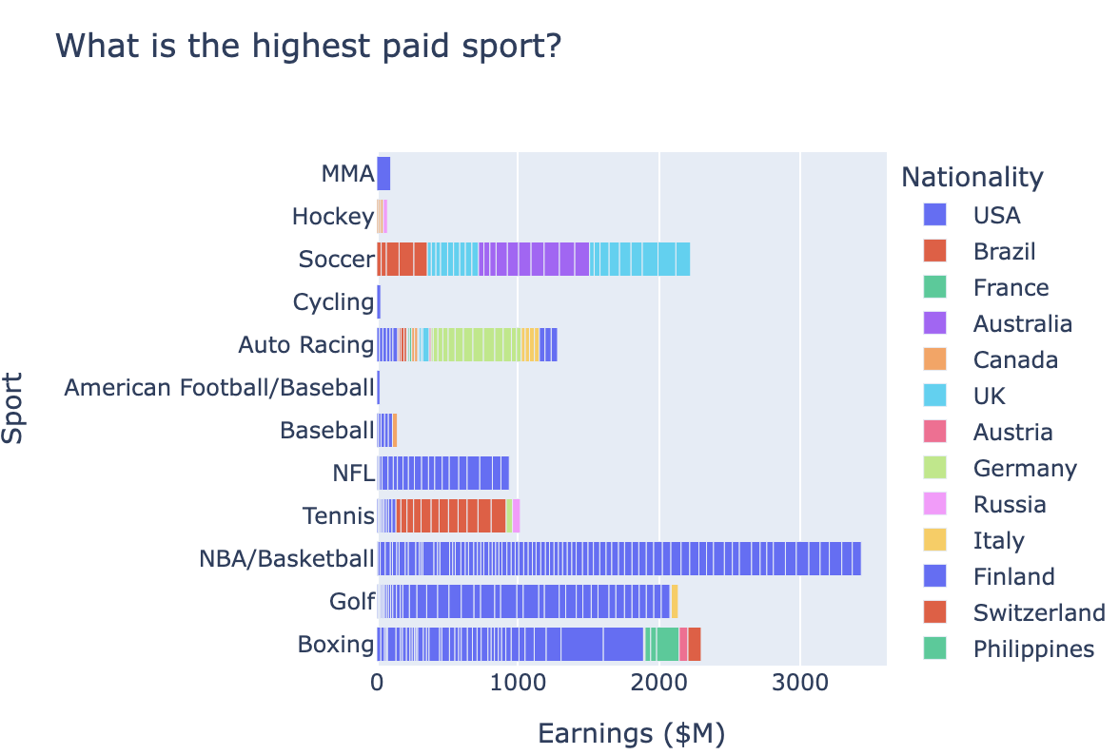
NBA/Basketball is the most popular and highest paid sport, followed by golf and boxing.
- Individual sport evolution over years by earnings
It seems that boxing, golf and NBA/Basketball had consistent and growing year on year earnings;
Auto racing seems to have lost popularity and decreased earnings in recent years;
Soccer is on a fast uptrend on earnings for the past 10 years.
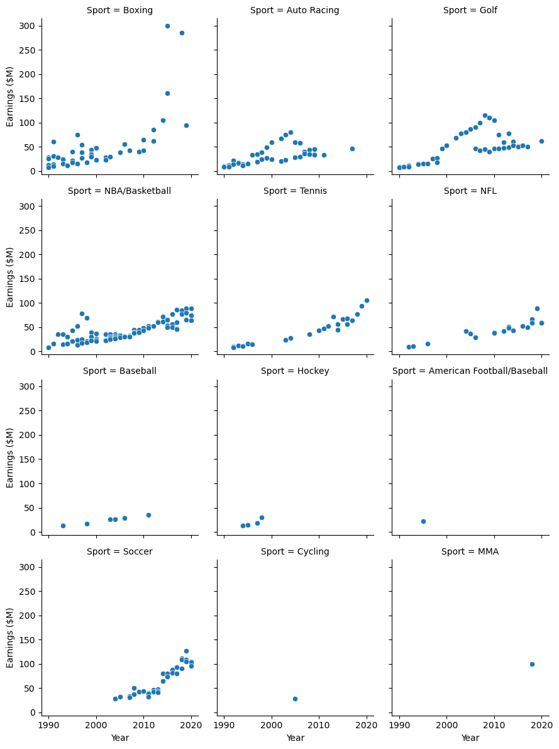
- First ranked players by year of selection
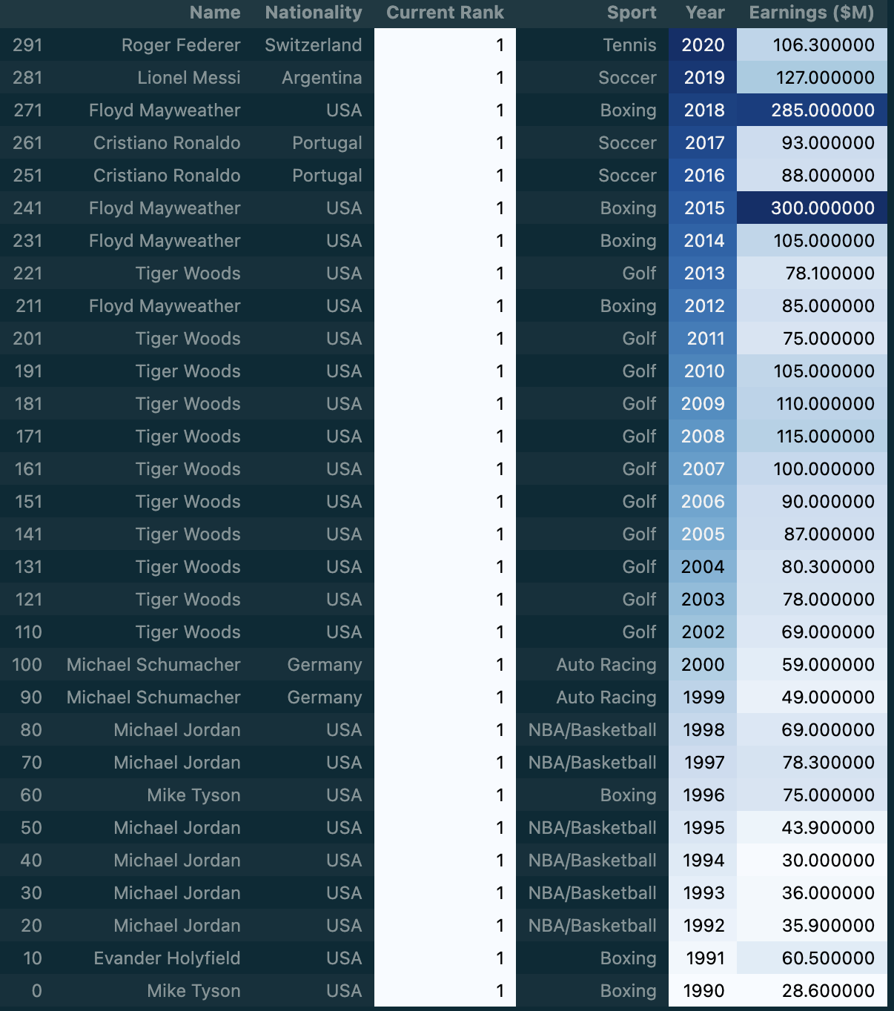

- How many times a player has been ranked first?
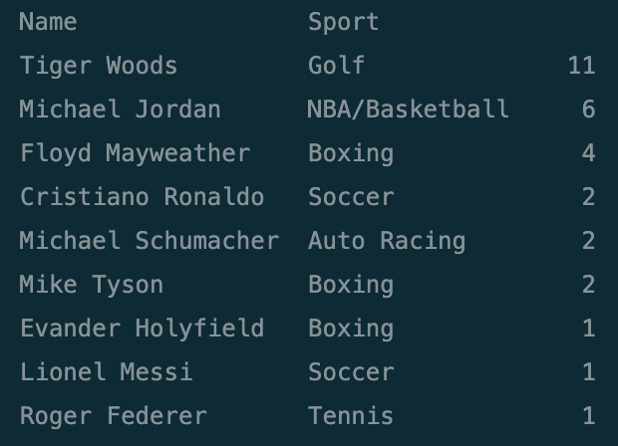
The golf player, Tiger Woods, has been ranked first for 11 times, more than anyone else in the given period of time
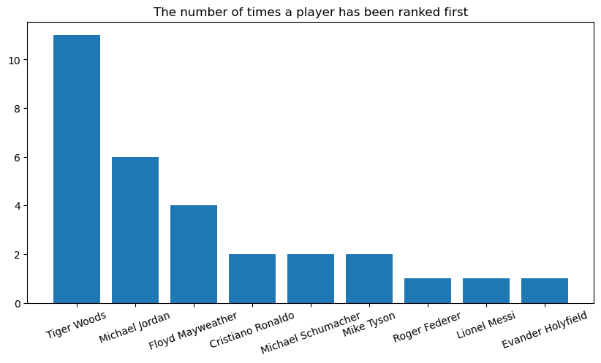
- The highest paid player by year
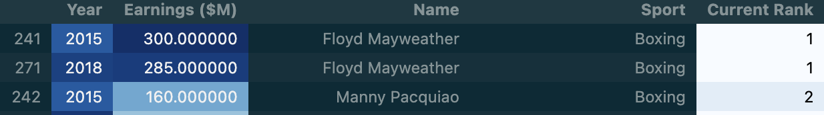
$300M was the top contract paid to box player Floyd Mayweather in 2015.
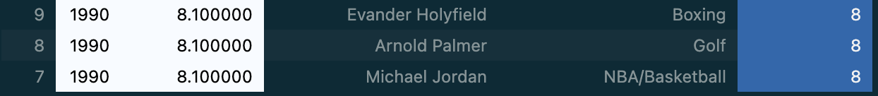
Basketball player Michael Jordan, together with box player Evander Holyfield and golf player Arnold Palmer had the lowest contract of $8M each in 1990.
- All time highest paid players
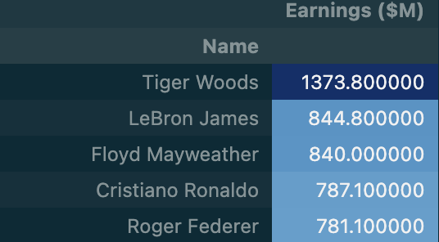
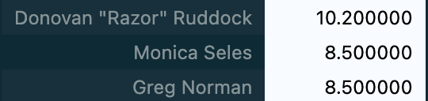
Tiger Woods had the top accumulated earnings, $1371.8M from 1990 to 2020.
Greg Norman and Monica Seles were the lowest paid players with each getting a total of $8.5 million.

- Gender representation
Women are underrepresented, with only female tennis player Monica Seles joining the list in 1992.

THIS REPORT WAS WRITTEN BY: Vivi Tilita

